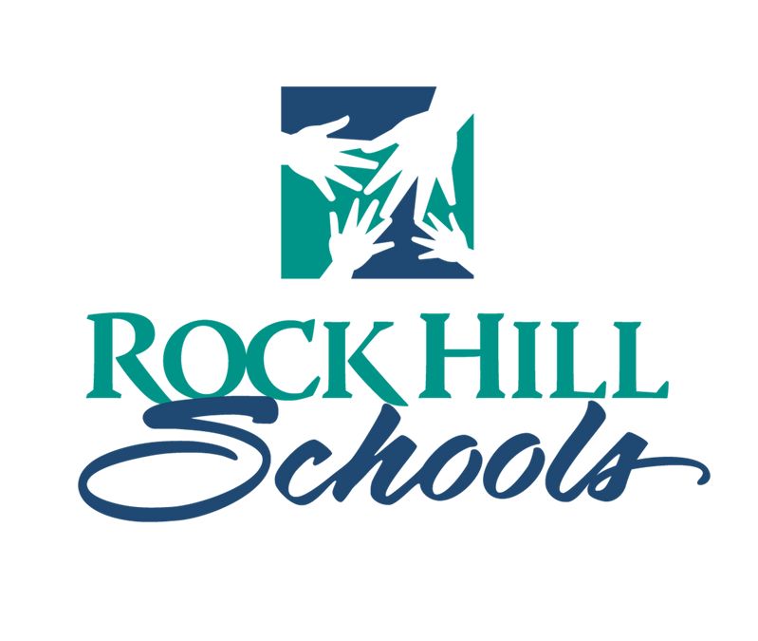

**Rock Hill Schools General Information about Title I**

**WHAT IS TITLE I?** Title I is a law under the Elementary and Secondary Education Act (ESEA) of 1965 which provides federal funds for compensatory educational services. Compensatory means "extra." Title I provides extra teachers, instructional assistants, funding for staff development, additional materials and additional supplies in the areas of reading and math for eligible schools. Title I programs offer opportunities for parents to make suggestions and recommendations regarding programs and use of Title I funds.

**WHICH SCHOOLS ARE ELIGIBLE?** In the Rock Hill Schools, elementary schools are eligible for Title I services based on their Pupils in Poverty (PIP) data. This year, schools with a PIP percentage of 68% or higher were identified for Title I support.

Title I schools for 2024-2025 are: Ebenezer, Ebinport, Independence, Northside, Oakdale, The Palmetto School, Richmond Drive, Sunset Park, and York Road.

Charter Schools may be served by Title I if the school meets eligibility requirements. The Palmetto School is being served under Title I during the 2024-2025 school year.

Schools with a Pupils in Poverty (PIP) percentage rate less than 40% are called Title I **Targeted-Assistance** schools. This year, the Rock Hill Schools do not have any **Targeted-Assistance** schools.

Schools where 40% or more of the students are identified as PIP are eligible for **Schoolwide** programs. **Schoolwide** programs will be operating during the 2024-2025 school year in the schools listed above. A **Schoolwide** program means that **all** students in the school are able to participate in services and the entire school is working toward higher achievement standards and acceleration for students in reading and math.

**WHO MAY PARTICIPATE?** All students in schools with **Schoolwide** programs benefit from these services. Services provided from Title I this year include: software for computer programs, support from Reading Recovery, Academic Interventionists, Math Coaches, Instructional Assistants, and Parenting Programs. Title I funds are used to purchase many leveled reading books, to purchase extra math materials and supplies, and to provide additional training and staff development for teachers in order to meet the needs of all students. Parent and Family engagement is encouraged in all Title I Schools through opportunities to serve on committees, offer recommendations and suggestions, and attend meetings and workshops.

**COMPARABILITY:** Because Title I funds are for supplemental educational services to students, districts must prove that they are spending the same amount of state and local funds for all pupils before using Title I funding. Rock Hill Schools uses the teacher/pupil ratio and size/split methods to demonstrate comparability.